CS 255 System Design Document Template

UML Diagrams

UML Use Case Diagram
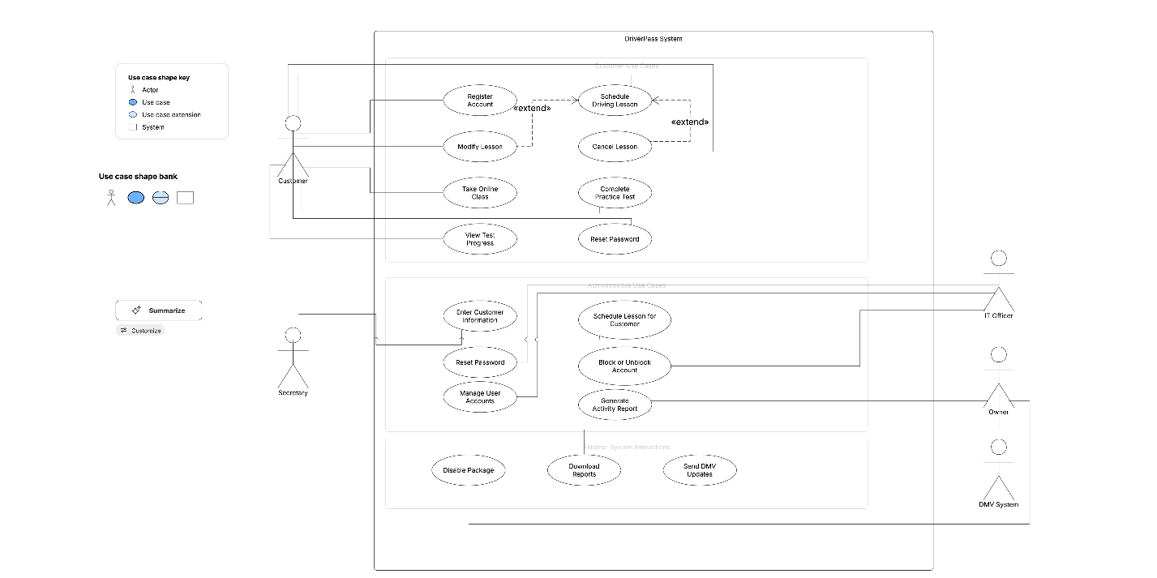

UML Activity Diagrams
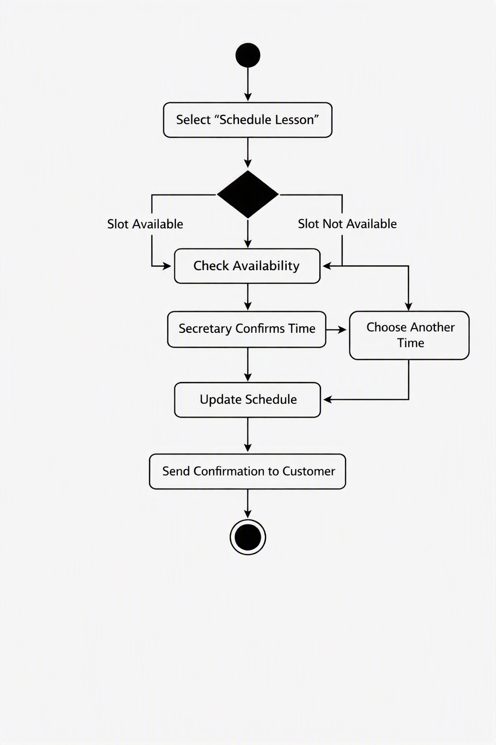

UML Sequence Diagram
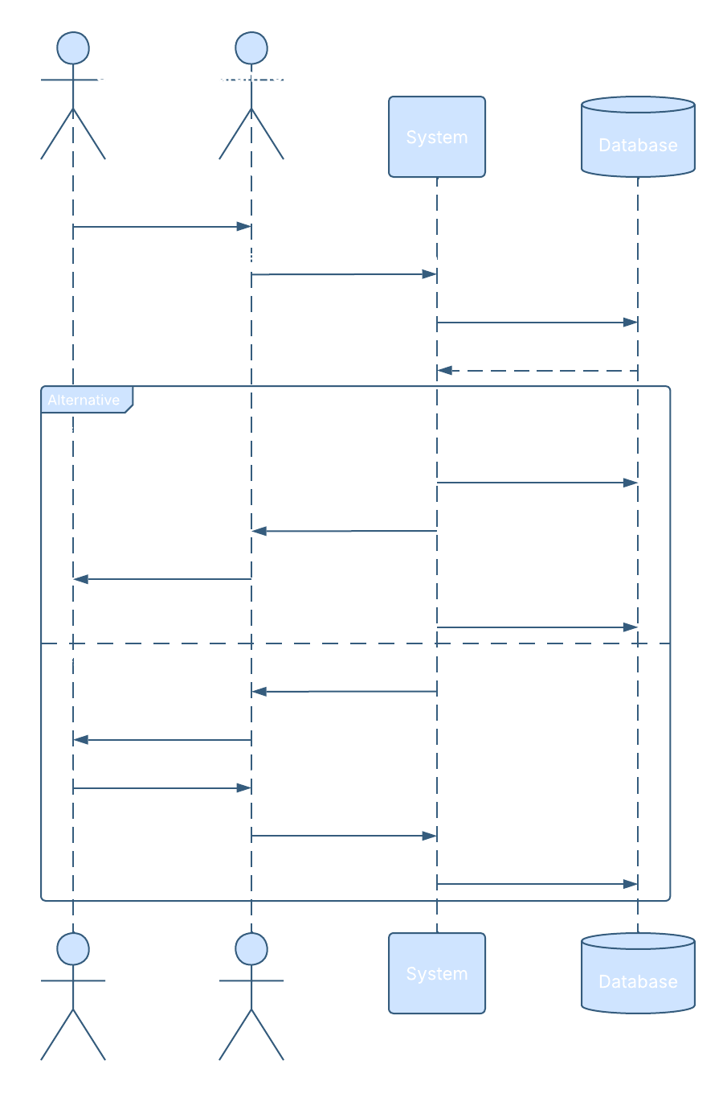

UML Class Diagram
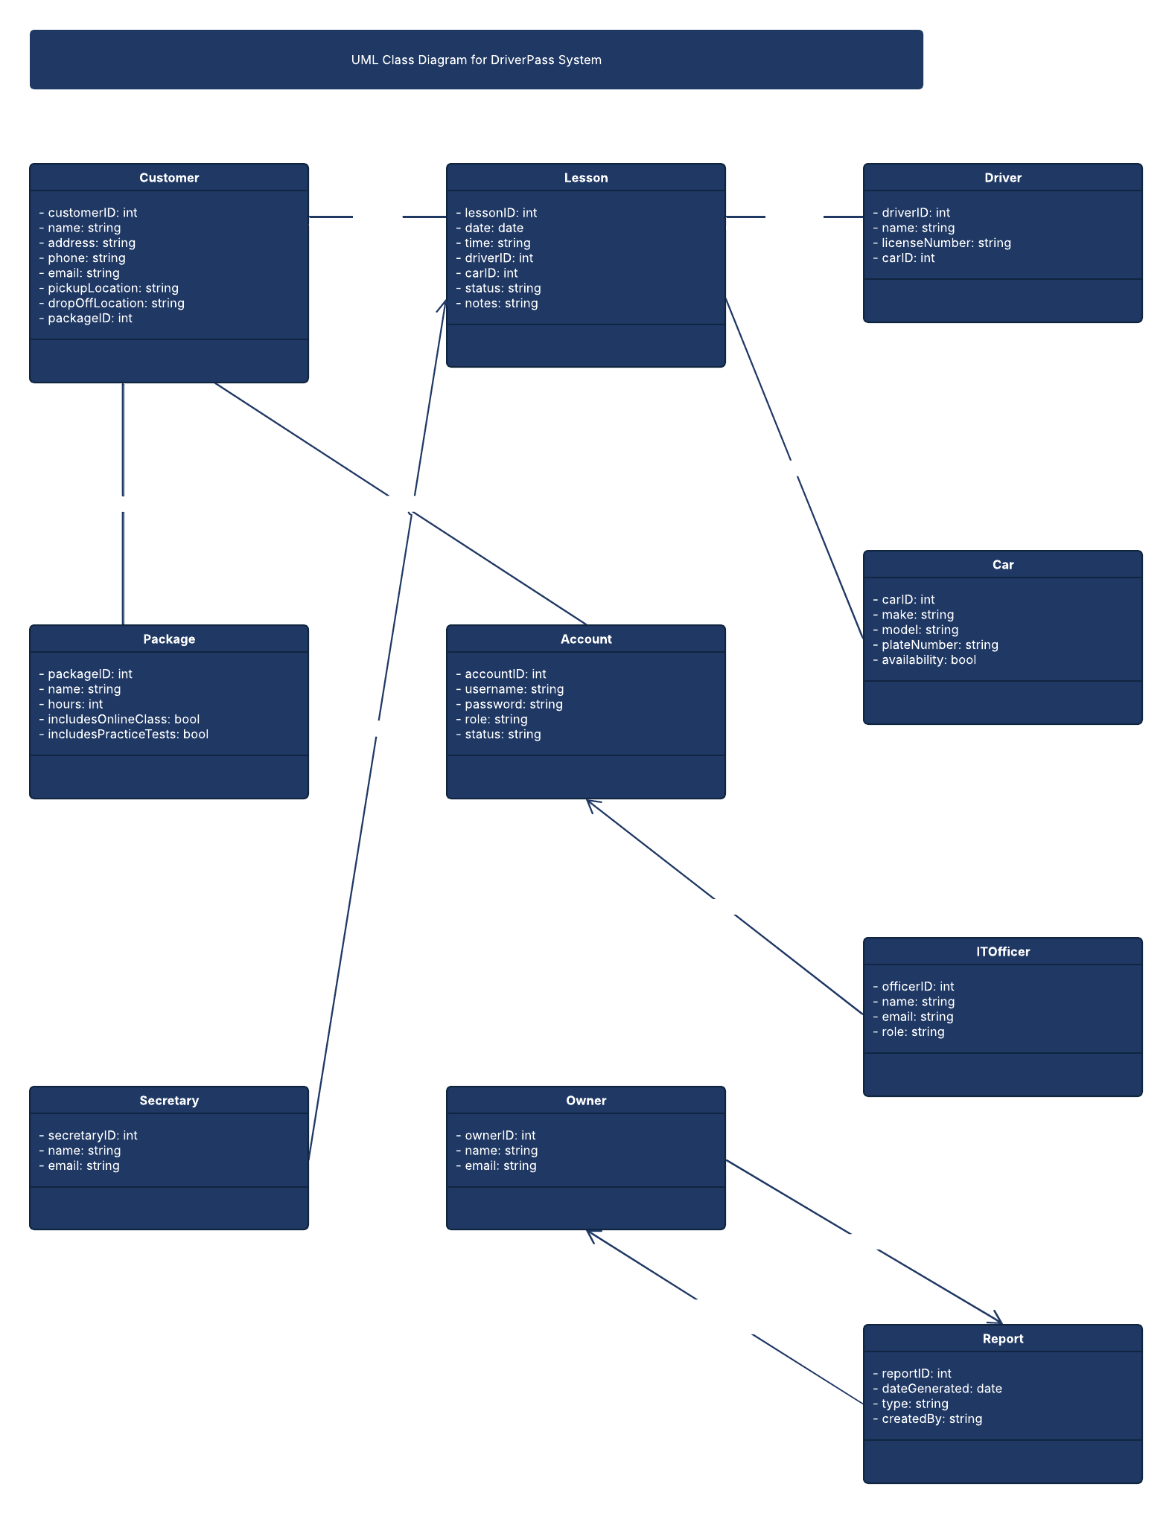

Technical Requirements
The DriverPass system requires a cloud-based web application that can be accessed from any computer or mobile device. The system must run on a secure cloud hosting environment to eliminate the need for local backups and reduce security risks. A web server is required to host the application, and a relational database server is needed to store customer information, lesson reservations, driver assignments, vehicle data, packages, test results, and activity logs.
The system must support secure communication between the client and server using encrypted connections (HTTPS/TLS). User authentication must be handled through a secure login system with role-based access control for customers, the secretary, the IT officer, and the owner. The IT officer must have full administrative access to reset passwords, block accounts, and manage user roles. Automated password recovery must be available for customers who forget their credentials.
The system must integrate with external DMV services to receive updated rules, policies, and test questions. This requires an API connection capable of receiving updates and triggering notifications within the system. The application must support downloading reports in formats such as Excel for offline review, while ensuring that all modifications to system data occur only online to prevent duplication or inconsistencies.
To support future growth, the system must be designed with modular components that allow new packages or features to be added later. The infrastructure must support scalability for increased numbers of users, lessons, and data. The system must also maintain detailed activity logs to track who created, modified, or canceled reservations for accountability and troubleshooting.
Overall, the technical requirements include:
- Cloud hosting environment
- Web server and relational database
- Secure encrypted communication
- Role-based access control
- Automated password reset functionality
- DMV API integration
- Report download capability
- Scalable and modular architecture
- Comprehensive logging and auditing

